samlogo_blue_pc.tif

**New Perspectives** Excel 2013

Tutorial 5: SAM Project 1a

Spring Software

WORKING WTH TABLES, PIVOTTABLES, AND PIVOTCHARTS

Project Goal

M Project Name

Project Goal

# PROJECT DESCRIPTION

Randall Jackson works in the Human Resources department of Spring Software, a software development company based in Cambridge, Massachusetts. Randall has created a workbook to store and analyze employee data. The workbook is comprised of individual worksheets for each of Spring Software’s regional offices, and a consolidated worksheet for all employees. Randall has asked you to edit some of the worksheet data, sort and filter selected tables to make the data more meaningful, and create PivotTables and PivotCharts.

# GETTING STARTED

* Download the following file from the SAM website:
  + **NP\_Excel2013\_T5\_P1a\_*FirstLastName*\_1.xlsx**
* Open the file you just downloaded and save it with the name:
  + **NP\_Excel2013\_T5\_P1a\_*FirstLastName*\_2.xlsx**
  + *Hint:* If you do not see the **.xlsx** file extension in the Save file dialog box, do not type it. Excel will add the file extension for you automatically.
* With the file **NP\_Excel2013\_T5\_P1a\_*FirstLastName*\_2.xlsx** still open, ensure that your first and last name is displayed in cell B6 of the Documentation sheet. If cell B6 does not display your name, delete the file and download a new copy from the SAM website.

# PROJECT STEPS

1. Go to the *Cambridge* worksheet. Unfreeze the top rows of the worksheet.
2. Sort the data in the *CambridgePayroll* table first in ascending order by the Statusfield and then in the ascending order by the LastNamefield.
3. Insert a **Total** **Row** in the*CambridgePayroll* table. (*Hint:* The Total Row should automatically total the values in the 2016 field.) Use the Total Row to calculate the total of the values in both the 2014and 2015fields.
4. Create a **PivotTable** based on *CambridgePayroll* table in a new worksheet titled **Cambridge PivotTable.** Update the PivotTable as described below so that it matches Figure 1 on the following page.
   1. Add the **Status** field and the **LastName** field (in that order) to the ROWSarea.
   2. Add the 2014, 2015, and 2016 fields (in that order) to the VALUES area.
   3. Update the Sum of 2014 field in the VALUES area to display the name **2014 Salaries** with the **Accounting** Number format with 0 decimal places.
   4. Update the Sum of 2015 field in the VALUES area to display the name **2015 Salaries** with the **Accounting** Number format with 0 decimal places.
   5. Update the Sum of 2016 field in the VALUES area to display the name **2016 Salaries** with the **Accounting** Number format with 0 decimal places.

Figure 1: Cambridge PivotTable

a3 Row Labels b3 2014 Salaries c3 2015 Salaries d3 2016 Salaries
a4 expand icon FT b4 $518,000 c4 $542,000 d4 $567,000
a5 indented Campbell b5 $80,000 c5 $82,000 d5 $85,000
a6 indented Fahey b6 $67,000 c6 $70,000 d6 $74,000
a7 indented Gonzalez b7 $88,000 c7 $90,000 d7 $93,000
a8 indented Jackson b8 $53,000 c8 $60,000 d8 $63,000
a9 indented Lang b9 $75,000 c9 $77,000 d9 $80,000
a10 indented Miller b10 $75,000 c10 $80,000 d10 $86,000
a11 indented Walsh b11 $80,000 c11 $83,000 d11 $86,000
a12 expanded icon PT b12 $169,000 c12 $172,500 d12 $196,500
a13 indented Brown b13 $30,000 c13 $32,000 d13 $35,000
a14 indented Chang b14 $24,000 c14 $15,000 d14 $25,000
a15 indented Dickenson b15 $15,000 c15 $18,000 d15 $18,000
a16 indented Foster b16 $35,000 c16 $32,000 d16 $35,000
a17 indented Kosteczki b17 $20,000 c17 $25,000 d17 $28,000
a18 indented Shao b18 $25,000 c18 $26,500 d18 $27,500
a19 indented Stanosky b19 $20,000 c19 $24,000 d19 $28,000
a20 Grand Total b20 $687,000 c20 $714,500 d20 $763,500

Microsoft product screenshot reprinted with permission from Microsoft Incorporated. Copyright © 2014 Cengage Learning. All Rights Reserved.

1. Go to the *Waltham* worksheet and complete the following steps.
   1. Sort the table by the Status field in ascending order.
   2. Convert the table to a normal range. (*Tip:* This option is only available if you do not select the header rows.)
   3. Insert subtotals into the range A3:G10, with the subtotals appearing at each change in the **Status** column value.
   4. The subtotals should use the **SUM** function and include subtotals for the **2014**, **2015**, and **2016** fields. (*Note*: Make sure to check the summary below data check box if it is not checked automatically.)
2. Go to the *Nashua* worksheet. Create an Excel table with headers based on the range A3:G8. Rename the table *NashuaPayroll* and format the table using the **Table Style Medium 10** (3rd column, 2nd row in the Medium Table Style section).
3. Add the following record as shown in bold in Table 1 below to the end of the *NashuaPayroll* table:

Table 1: New Record for NashuaPayroll Table

# 

|  |  |  |  |  |  |  |
| --- | --- | --- | --- | --- | --- | --- |
| LastName | FirstName | Office | Status | 2014 | 2015 | 2016 |
| **Chouhan** | **Danielle** | **Nashua** | **PT** | **$32,000** | **$33,000** | **$36,000** |

© 2014 Cengage Learning.

1. Go to the *Framingham* worksheet and filter the *FraminghamPayroll* table to show only those records with a Statusfield value of **PT**.
2. Delete the duplicate record for Mary Nichols from the *FraminghamPayroll* table
3. Go to the *All Employees* worksheet and freeze the top row of the *All Employees* worksheet.
4. Use the **Find** command to find the record for employee Brianne Brown. Edit the record by changing the 2016field value to **$34,000**. Close the Find and Replace dialog box.
5. Filter the table to show only records for employees who work part-time (*Hint*: Status field equals “PT”) and who had a 2016 salary greater than or equal to $30,000.

*Refer to Figure 2 on the following page while completing Steps 13-17.*

Figure 2: Employees PivotTable Worksheet

a1 Status b1 PT filter icon
a3 Row Labels filter icon b3 2014 Salaries c3 2015 Salaries d3 2016 Salaries
a4 expanded icon Cambridge b4 $174,00 c4 $182,500 d4 $205,500
a5 indented Brown b5 $30,000 c5 $32,000 d5 $34,000
a6 indented Chang b6 $24,000 c6 $15,000 d6 $25,000
a7 indented Dickenson b7 $15,000 c7 $18,000 d7 $18,000
a8 indented Foster b8 $40,000 c8 $42,000 d8 $45,000
a9 indented Kosteczki b9 $20,000 c9 $25,000 d9 $28,000
a10 indented Shao b10 $25,000 c10 $26,500 d10 $27,500
a11 indented Stanosky  b11 $20,000 c11 $24,000 d11 $28,000
a12 Grand Total b12 $174,000 c12 $182,500 d12 $205,500
slicer E3:G11
slicer title Office
slicer buttons top to bottom Cambridge (selected) Framingham Nashua Waltham 

Copyright © 2014 Cengage Learning. All Rights Reserved.

1. Switch to the *Employees PivotTable* worksheet. **Refresh** the *PivotTable* data. (*Hint:* After refreshing the PivotTable, the Brown record in row 5 should now have a 2016 salary field value of $34,000.)
2. Apply the **Pivot Style Medium 10** PivotTable style to the PivotTable.
3. Update the Sum of 2014 field in the VALUES area to display the name **2014 Salaries** with the **Accounting** Number format with 0 decimal places.
4. Create a **Filter** for the PivotTable by adding the **Status** field to the FILTERSarea.Filter the table so that only employees with a PT status are visible.
5. Create a **Slicer** that will filter the PivotTable based on the Officefield value. Resize the slicer so that it has a height of **1.75”** and a width **1.5**”. Move the slicer so that its top-left corner appears in cell E3. Finally, use the slicer to filter the PivotTable so that only employees from the Cambridge office are visible.
6. Switch to the *Office PivotTable* worksheet. **Refresh** the *PivotTable* data. Insert a **PivotChart** with the **Clustered Column** Chart type. Update the PivotChart as described below to match Figure 3 on the following page.
7. Move and Resize the PivotChart so that the top-left corner is in cell E3 and the bottom- right corner is in cell P26.
8. Add the chart title **Yearly Salaries by Office Location** to the PivotChart using the Above Chart option.
9. Use the Status axis field button to filter the PivotChart so that only the salary of part-time employees at each office location appears in the graph.

Figure 3: Office PivotTable Worksheet

# a3 Row Labels filter icon b3 2014 Salaries c3 2015 Salaries d3 2016 Salaries a4 expanded icon Cambridge b4 $174,000 c4 $182,500 d4 $205,500 a5 indented PT b5 $174,00 c5 $182,500 d5 $205,500 a6 expanded icon Framingham b6 $58,000 c6 $61,500 d6 $64,000 a7 indented PT b7 $58,000 c7 $61,500 d7 $64,000 a8 expanded icon Nashua b8 $99,600 c8 $103,800 d8 $111,000 a9 indented PT b9 $99,600 c9 $103,800 d9 $111,000 a10 expanded icon Waltham b10 $50,500 c10 $52,500 d10 $54,500 a11 indented PT b11 $50,500 c11 $52,500 d11 $54,500 a12 Grand Total b12 $382,100 c12 $400,300 d12 $435,000 chart E3:P26 upper left chart corner buttons 2014 Salaries, 2015 Salaries, 2016 Salaries none selected chart title Yearly Salaries by Office Location veritcal axis $0 to $250,000 by $50,000 increments horizontal axis PT Cambridge, PT Framingham, PT Nashua, PT Waltham chart bottom left corner buttons Office, Status none selected legend at right legend title Values legend entries top to bottom 2014 Salaries, 2015 Salaries, 2016 Salaries

Copyright © 2014 Cengage Learning. All Rights Reserved.

# Your workbook should look like the Final Figures on the following pages. Save your changes, close the workbook, and exit Excel. Follow the directions on the SAM website to submit your completed project.

# Final Figure 1: Cambridge PivotTable

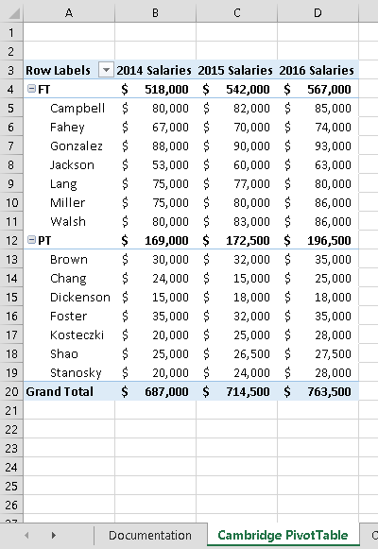

Microsoft product screenshot reprinted with permission from Microsoft Incorporated. Copyright © 2014 Cengage Learning. All Rights Reserved.

# Final Figure 2: Cambridge Worksheet

Copyright © 2014 Cengage Learning. All Rights Reserved.

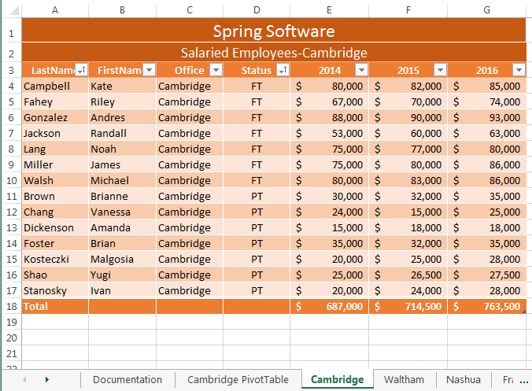

# Final Figure 3: Waltham Worksheet

**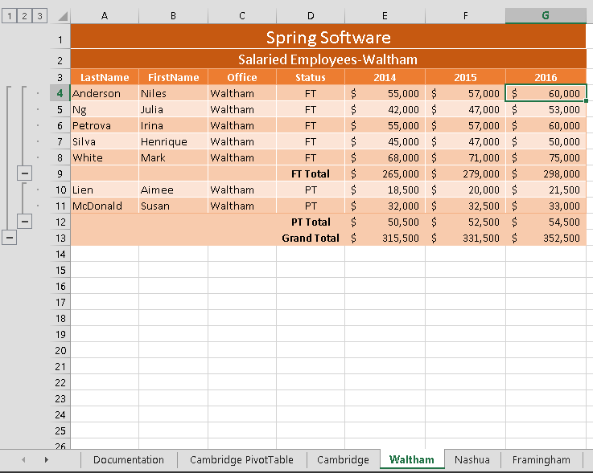**

Copyright © 2014 Cengage Learning. All Rights Reserved.

# Final Figure 4: Nashua Worksheet

**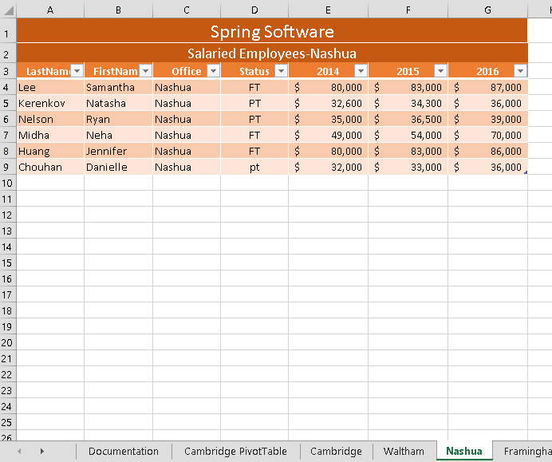**

Copyright © 2014 Cengage Learning. All Rights Reserved.

# Final Figure 5: Framingham Worksheet

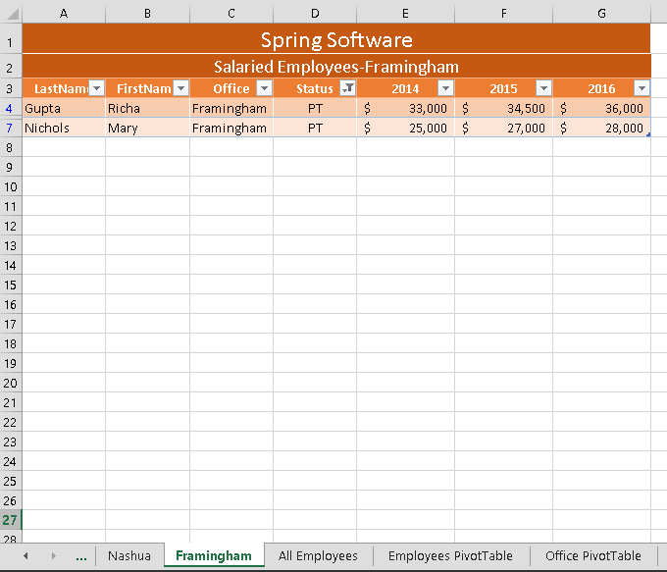

Copyright © 2014 Cengage Learning. All Rights Reserved.

# Final Figure 6: All Employees Worksheet

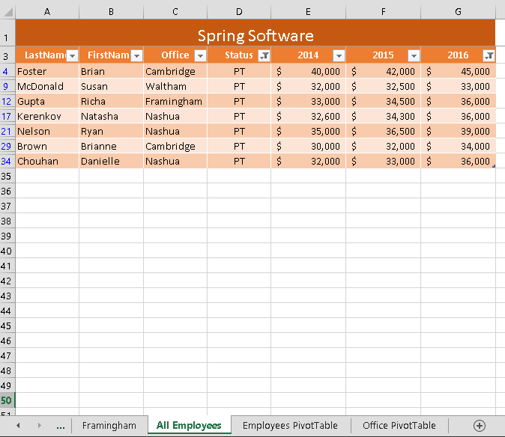**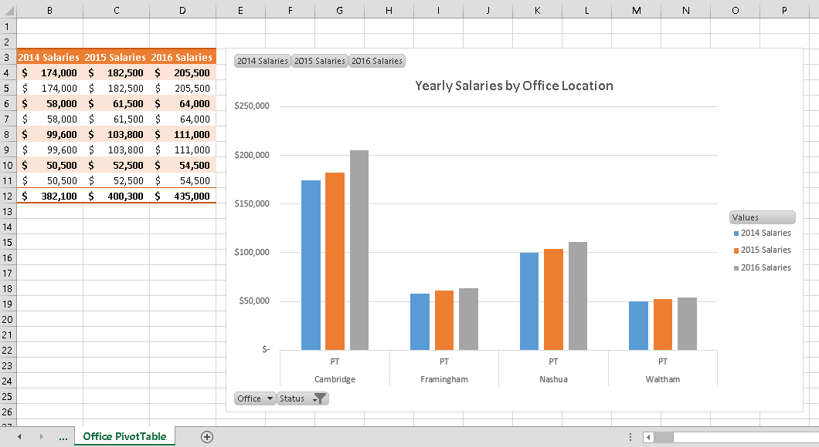**

Copyright © 2014 Cengage Learning. All Rights Reserved.

# Final Figure 7: Employees PivotTable

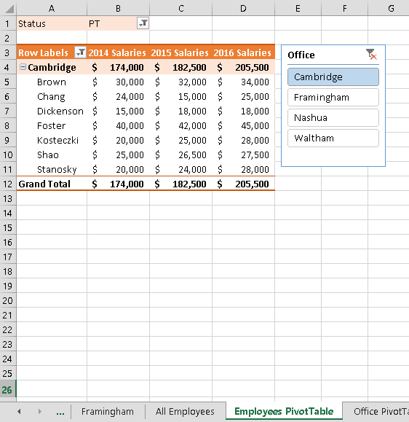

Copyright © 2014 Cengage Learning. All Rights Reserved.

# Final Figure 8: Office PivotTable

**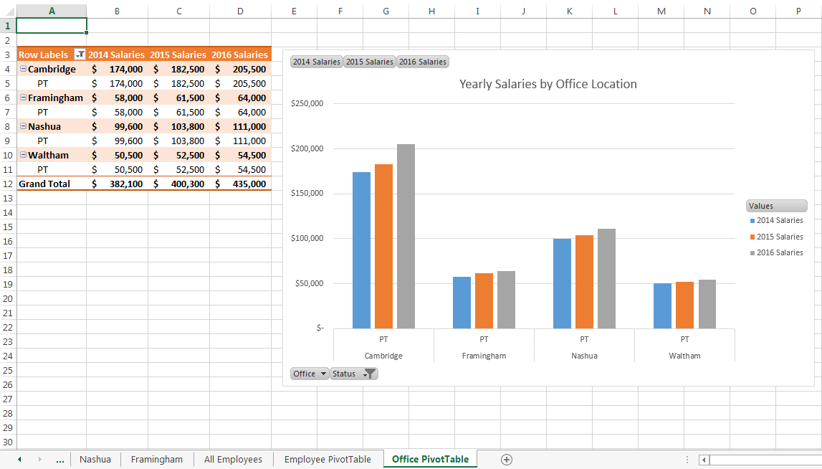**

Copyright © 2014 Cengage Learning. All Rights Reserved.